***Merge two Sorted Arrays***

Given two sorted arrays, the task is to merge them in a sorted manner.  
**Examples:**

***Input****: arr1[] = { 1, 3, 4, 5}, arr2[] = {2, 4, 6, 8}*  
***Output****: arr3[] = {1, 2, 3, 4, 4, 5, 6, 8}*

***Input****: arr1[] = { 5, 8, 9}, arr2[] = {4, 7, 8}*  
***Output****: arr3[] = {4, 5, 7, 8, 8, 9}*

**Method 1: (O(n1 * n2) Time and O(n1+n2) Extra Space)**

1. Create an array arr3[] of size n1 + n2.
2. Copy all n1 elements of arr1[] to arr3[]
3. Traverse arr2[] and one by one insert elements (like [insertion sort](https://www.geeksforgeeks.org/insertion-sort/)) of arr3[] to arr1[]. This step take O(n1 * n2) time.

We have discussed implementation of above method in [Merge two sorted arrays with O(1) extra space](https://www.geeksforgeeks.org/merge-two-sorted-arrays-o1-extra-space/)  
**Method 2: (O(n1 + n2) Time and O(n1 + n2) Extra Space)**   
The idea is to use Merge function of [Merge sort](https://www.geeksforgeeks.org/merge-sort/).

1. Create an array arr3[] of size n1 + n2.
2. Simultaneously traverse arr1[] and arr2[].
   * Pick smaller of current elements in arr1[] and arr2[], copy this smaller element to next position in arr3[] and move ahead in arr3[] and the array whose element is picked.
3. If there are remaining elements in arr1[] or arr2[], copy them also in arr3[].

Below image is a dry run of the above approach:

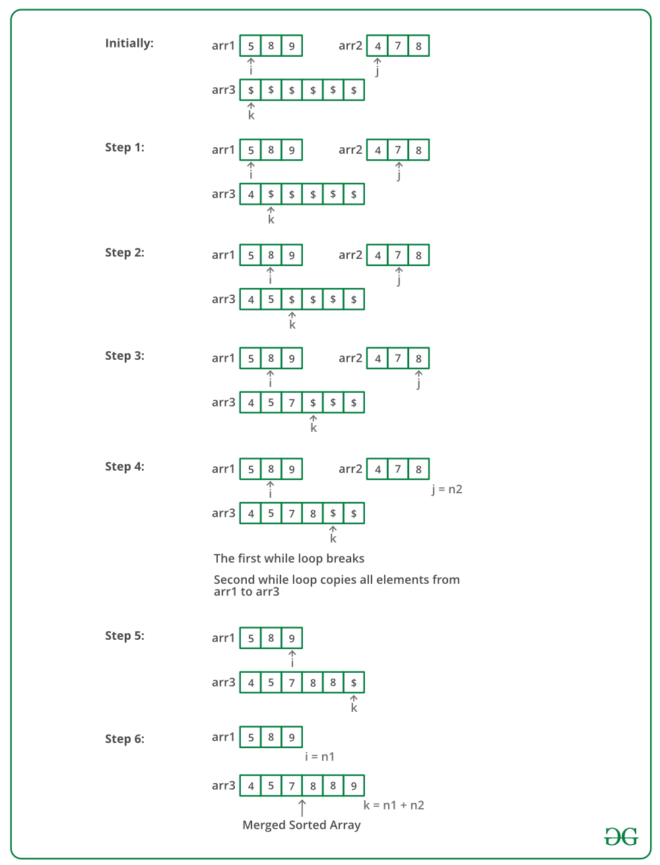

Below is the implementation of the above approach:

C++

#include <bits/stdc++.h>

using namespace std;

void mergeArrays(int arr1[], int arr2[], int n1, int n2, int arr3[]) {

int i = 0, j = 0, k = 0;

while (i < n1 && j < n2) {

if (arr1[i] < arr2[j])

arr3[k++] = arr1[i++];

else

arr3[k++] = arr2[j++];

}

while (i < n1)

arr3[k++] = arr1[i++];

while (j < n2)

arr3[k++] = arr2[j++];

}

int main() {

int arr1[] = {1, 3, 5, 7};

int n1 = sizeof(arr1) / sizeof(arr1[0]);

int arr2[] = {2, 4, 6, 8};

int n2 = sizeof(arr2) / sizeof(arr2[0]);

int arr3[n1+n2];

mergeArrays(arr1, arr2, n1, n2, arr3);

cout<<"Array after merging"<<"\n";

for (int i = 0; i < n1+n2; i++)

cout<<arr3[i]<<" ";

return 0;

}

**Output**

Array after merging

1 2 3 4 5 6 7 8